Q2.Create a new database called InstaClone in MySQL Workbench, then create a table named Users with columns: user_id (INT, primary key), username (VARCHAR), email (VARCHAR), and followers_count (INT).
ANS:
Query:
CREATE DATABSE Instaclone;
USE Instaclone;
CREATE TABLE users(user_id int PRIMARY KEY, username varchar(100),email varchar(40), followers_count int);
Output: 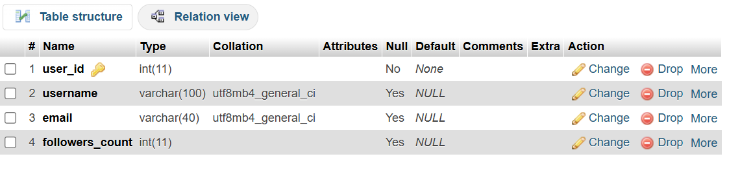
Q3. Insert 3 sample users into the Users table you created, using realistic Instagram-style usernames and follower counts.
ANS:
Query:
INSERT INTO users (user_id, username,email,followers_count)VALUES(1,'yahya','yahybalesaria@gmail.com',3107),(2,'zaid','zaid@gmail.com',2356),(3,'aman','amanshaikh@gmail.com',4563);
SELECT * FROM users;
Output: 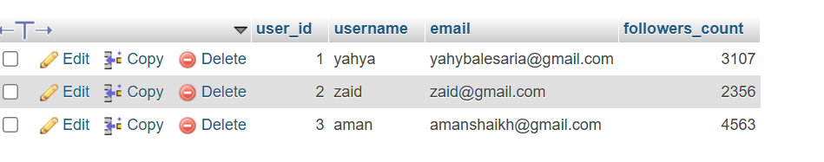
Q.4 Create another table in the InstaClone database called Posts with columns: post_id (INT, primary key), user_id (INT), caption (VARCHAR), and post_date (DATE). Add a foreign key from Posts.user_id to Users.user_id to establish a relationship.
ANS:
Query: USE Instaclone;
CREATE TABLE posts (post_id int PRIMARY KEY,user_id int, caption varchar(100),post_date date,FOREIGN KEY(user_id) references users(user_id));
Output: 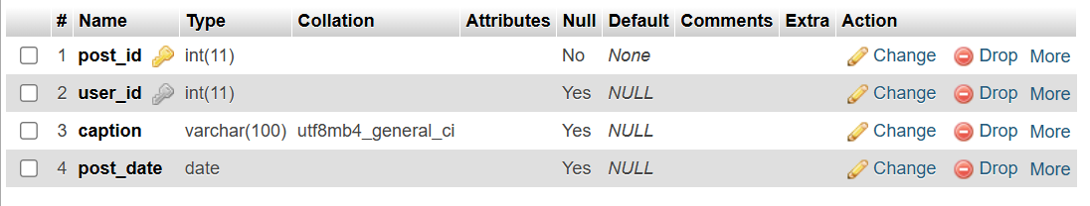
Q.5.Write a short comparison (3-4 lines each) of MySQL, PostgreSQL, Oracle, and SQLite, focusing on where each one is commonly used (for example: web apps, mobile apps, enterprise systems, etc.).
ANS: A) MYSQL:
MYSQL is an open source relational database management system.
It is commanly used for websites and web applications.It is widely used with technolgies like PHP,Python and Java.It is suitable for both small and large web projects.
B)PostgreSQL:
PostgreSQL is an open source relational database management system.
It is commanly used for web aoolication and data intensive projects.It supports complex queries and advanced database features.It is also used in business and enterprise applications.
C)Oracle:
Oracle is a commercial relational database management system.
It is commanly used by large companies and enterprise organisations.It is widely used in banking,finance and other large business systems.It is designed to manage large amount of business data.
D)SQLite:
SQLite is a lightweight and serverless relational database.
It is commonly used in mobile applications and desktop applications.
It is also used in embedded systems and small projects.
It stores the database in a single file and does not require a separate server.

